OSYS 1000 Exercise 15

**UNIX**

# Instructions

**This exercise is a series of steps you will complete on the CentOS Terminal interface. Therefore, you must have your virtual machine installed as per the “CentOS Installation” video.**

1. While moon-buggy was fun, we need some more terminal-based excitement. Check out the following link:
   1. <https://github.com/alexdantas/nSnake>
2. We are not going to bother with either the script command or creating an executable shell script for today’s in-class activity. You can simply take screenshots of setting up nsnake (i.e. **Steps 3 – 13**) and save them in a Word document (e.g. “Ex15_Mike_Crocker.docx”).
3. You may want to perform the following procedure inside the **/tmp** folder.
4. You will need to install the following before you can install this:
   1. yum group install "Development Tools"
   2. yum install ncurses-devel ncurses
5. We can down load the latest source code from the following link:
   1. <https://sourceforge.net/projects/nsnake/files/GNU-Linux/nsnake-3.0.1.tar.gz>

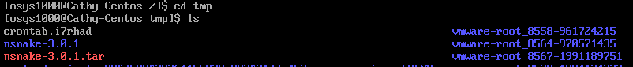

1. Download nsnake from the link above using wget.
2. Uncompress and untar the source code.
3. We do not need to run ./config as nsnake already comes with a MAKEFILE so we just need to do Step 2 (i.e. make) and Step 3 (i.e. sudo make install) of our usual 3-Step process to install from source. This would be done inside the extracted folder. Go into the folder
4. After building and installing the executable file, you may need to set your font size back to the original in your /etc/vconsole.conf file and reboot. Ask the instructor for help.
5. Run the game by typing “nsnake”.
6. Play nsnake.
7. Since we have the Source code (i.e. in the src subfolder), see if you can make a change (e.g. show a whimsical title in the game somewhere as I have done for “Main Menu” in the screen show below).

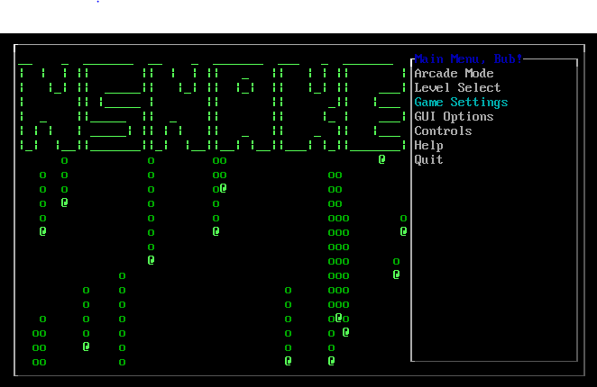

1. In order to make a change to the application, you may want to perform the following after changing a source file:
   1. sudo make uninstall
   2. make clean
   3. make
   4. sudo make install
2. You might want to set your font back as per Step 9.
3. Post the Word document with your screenshots to the D2L Dropbox for the fifteenth in-class exercise in order to obtain credit for completing it.
4. That’s it.